

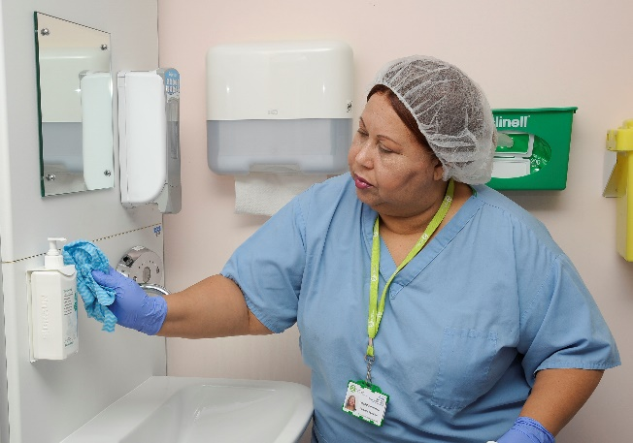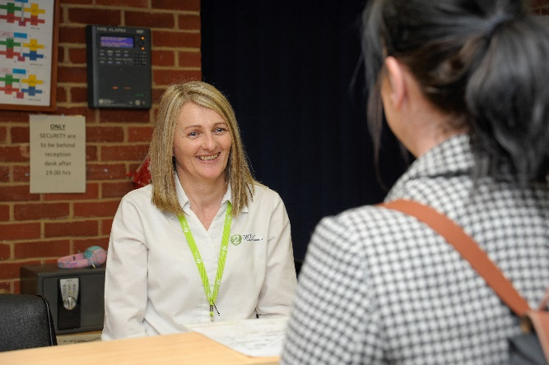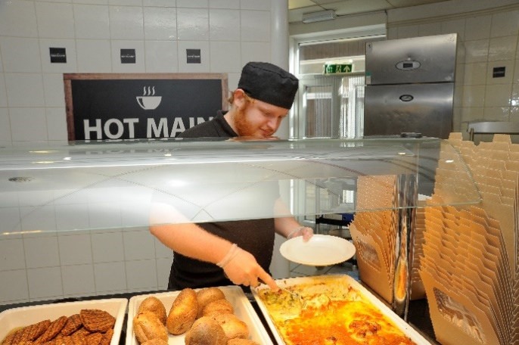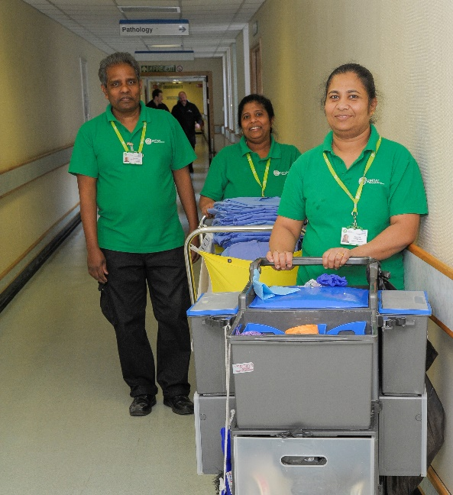

Candidate

Housekeeper

**information**

**Housekeeper**

Thank you for your interest in the **Housekeeper** role here at 2gether Support Solutions. This is a great time to join us as we continue our journey to be recognised as an employer of choice in East Kent.

We want to recruit people who share our ambition and vision to deliver a high standard of service. We understand that our teams make an important difference to patients, visitors and clinical staff; and having the right people in the right roles is crucial to this.

Our in-house talent team look forward to receiving your application and I wish you the best of luck.

Matthew Baker, People Director

**Our recruitment process**

**About 2gether Support Solutions**



We were formed in 2018, by East Kent Hospitals University NHS Foundation Trust (EKHUFT),

and provide total facilities management services along with a range of business support

including procurement, medical engineering and capital build projects.

2gether Support Solutions employs over 1,300 people and our core customer is East Kent Hospitals, managing five hospitals over 210,000sqm of estate at:

* William Harvey Hospital in Ashford,
* Queen Elizabeth The Queen Mother Hospital in Margate,
* Buckland Hospital in Dover,
* Royal Victoria Hospital in Folkestone; and
* Kent and Canterbury Hospital in Canterbury.

Now is a really exciting time to join 2gether, as the company continues to play a key role in supporting local communities, staff and clinical care. Find out more about what we do by visiting [www.2getherSupportSolutions.org](http://www.2getherSupportSolutions.org)

**What we are all about**

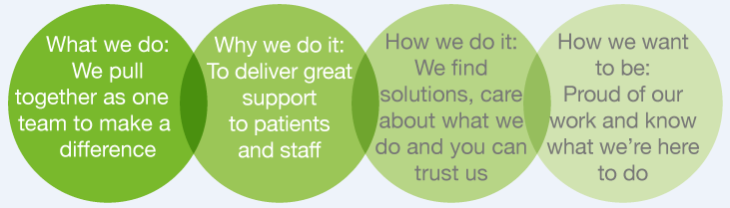

**How to apply**

Via our website: <https://2gethersupportsolutions.org/careers/>

By email: [2gether.recruitment@nhs.net](mailto:2gether.recruitment@nhs.net)

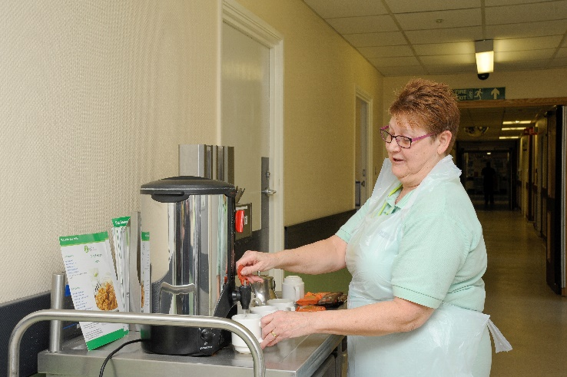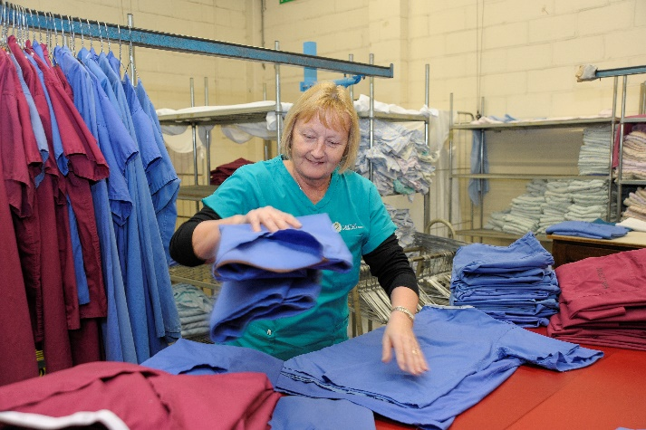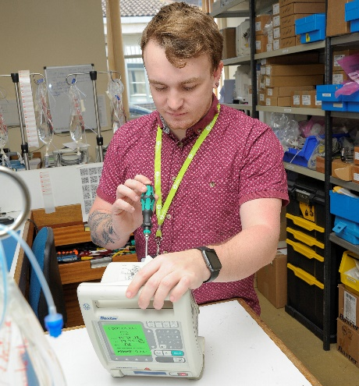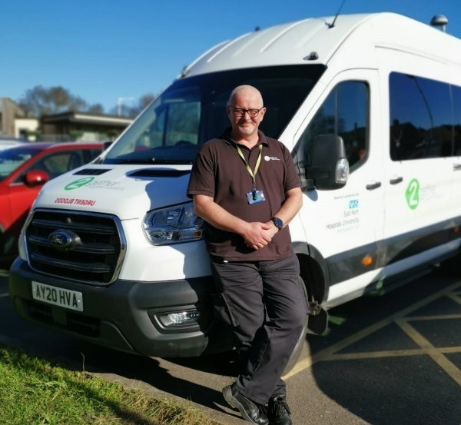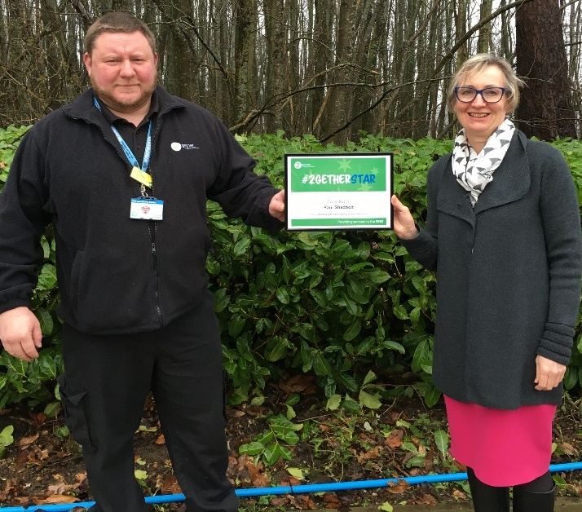

**Organisation chart *(to be supplied by department)***

**Job Description**

|  |  |  |
| --- | --- | --- |
| **Role title:** Housekeeper | **Role reference:** |  |
| **Summary of the role:**  The role is to deliver a nutritious food and beverage service that meets each patients’ dietary needs. The Housekeeper will liaise frequently with patients, dieticians, kitchen team and clinical staff in the performance of their duties. They will have responsibility for their own ward kitchen including stock management, regulatory paperwork and cleaning standard adherence. This role is a critical role to assist with the patients care journey through the hospital and requires strong communication and customer service skills. The role requires the postholder to spend long periods of time walking, lifting and pushing trolleys across the sites. | | **Reports to:**  Domestic Team Leader |
| **Base / location:**  TBC |
| **Key responsibilities** | | **Working relationships & contacts** |
| * Responsible for the preparation and delivery of meal and beverage services to patients in any area of the hospital as required. This includes Inpatient Wards, Maternity units and Emergency Departments and Outpatients areas as required. * Liaise with clinical staff to ascertain specific patient dietary requirements potentially impacting on the unique clinical and nutritional needs. * Greet and talk confidently to patients concerning their individual meal and beverage requirements. Record and relay their orders accurately to the kitchen teams. Maintaining a high standard of customer service to patients, visitors and staff. * Collect the meals from the kitchen, prepare them in the ward kitchen area and deliver them to the patient’s bedside. * Maintain strong food hygiene standards at all times in accordance with legislation. * Ensure all relevant HACCP documentation is completed. Maintain all records as required including stock management. Ordering stock for ward area and collecting it from the main kitchen. * Comply with 2gether Support Solutions policies on Health & Safety, COSHH, HACCP and other statutory legislation * Carry out duties in accordance with agreed Standard Operating Procedures. * Undertake cleaning tasks and removing both kitchen and ward waste where required. * Use equipment as per local protocols, reporting defects and communicating any issues internally. | | **Internal:** Staff on shift and other clinical staff from a number of departments.  **External:** Patients, visitors and other external clients. |
| **Performance measures and key performance indicators (KPIs)**  **(If required)** |
|  |

**Person Specification**

|  |  |  |
| --- | --- | --- |
| **Person Specification**  **(E) – Essential, (D) – Desirable** | | |
| **Knowledge and Skills:** | **Experience:** | **Qualifications and Professional Memberships:** |
| Good communication skills including verbal and written English. (E)  Food safety awareness (D)  Numerate/literate. (E)  Shows initiative and self-motivation. (E)  Friendly. (E)  Reliable. (E)  Attention to detail. (E)  Health and Safety Awareness (D)  Customer Care (E)  Fire Safety (D) | No formal experience is required as all staff will undertake a range of compulsory training courses prior to and during employment to ensure maintenance of high quality standards.  Previous knowledge of food preparation and allergies (D) | BICS training to Operator Proficiency Certificate Level 1 (OPC L1)  Level 2 Food safety  Level 2 Allergen Aware |

**Essential Health and Safety information**

|  |  |  |  |
| --- | --- | --- | --- |
| **Does the post involve…** |  | **Y** | **N** |
| **Confined spaces?** | A “confined space” means any enclosed place, such as may need to be accessed by estates staff for maintenance such as loft spaces, plant rooms or flues. |  | X |
| **Driving?** | This means driving a company vehicle, passenger carrying vehicle or transporting patients in own vehicle for work purposes. It does not include commuting or driving between places of work. |  | X |
| **Exposure to substances hazardous to health?** | This is where risk assessments have identified known health hazards (chemical, biological or radiological). For example, designated latex glove user. | X |  |
| **Hand arm vibration exposure?** | This includes hand held tools such as drills, saws, gardening tools, domestic cleaning tools and other power equipment. |  | X |
| **Hand washing?** | This means washing hands 20 plus times per working day. | X |  |
| **Lone working?** | This means employees who work by themselves without close or direct supervision. Lone working may be found in a wide range of situations, such as home or community visits, working alone outside normal hours, working in remote or confined areas (such as plant rooms). |  | X |
| **Manual handling?** | This means all job roles where there are specific manual handling / patient handling requirements. | X |  |
| **Night working?** | This means regular work at least 3 hours during the agreed ‘night period’ (usually includes 11pm to 6am). |  | X |
| **Noise exposure?** | This is where risk assessments have identified noise levels under the Noise at Work Regulations 2005, and is likely to include areas where ear protection is needed or workers regularly have to shout to communicate due to background noise. |  | X |
| **Work at heights?** | A place is ‘at height’ if a person could be injured falling from it. This includes working on ladders, up scaffold or any other apparatus. It may also apply to staff who regularly have to stand on kick-stools or steps for significant periods of time to retrieve items/ notes from high shelving. |  | X |