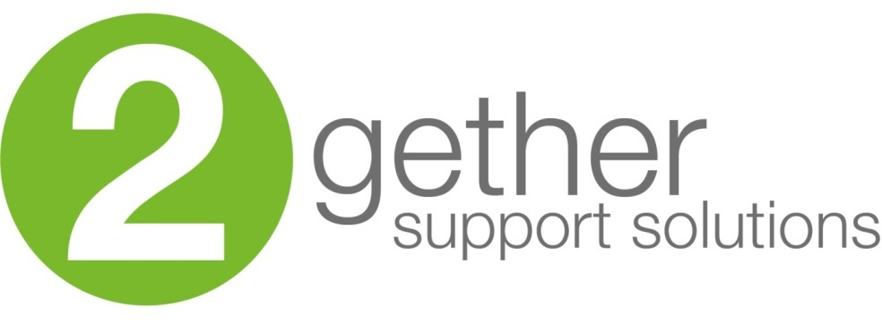
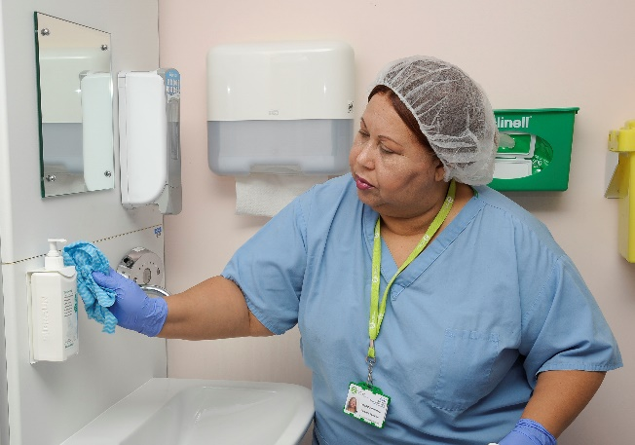
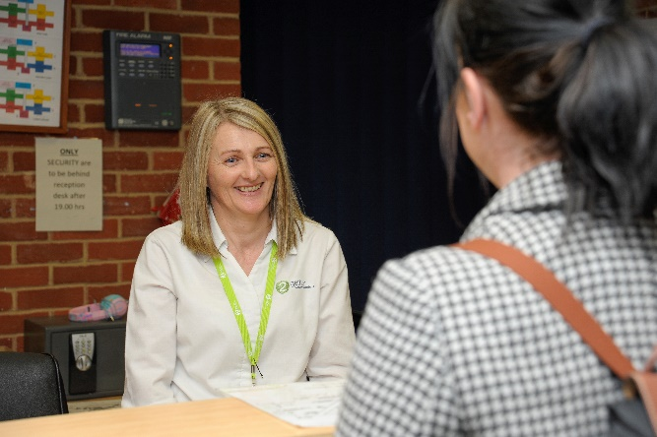
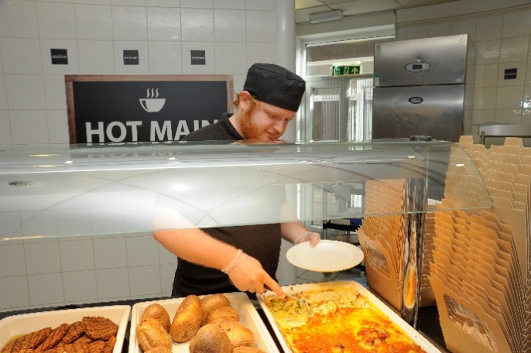
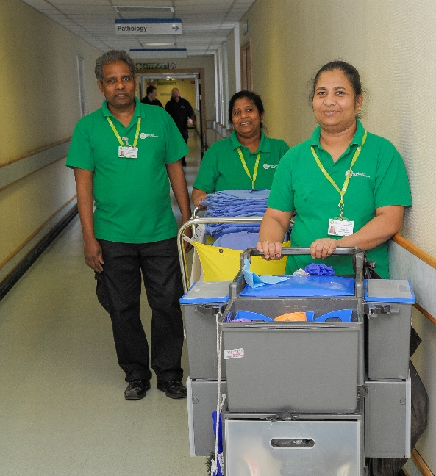
Service Desk Team Leader

Candidate
information
Organisation chart

Job Description

Role title: Service Desk Team Leader | Role reference: JD205
Summary of the role:  The Service Desk Team Leader at 2gether Support Solutions leads and motivates the front-line team to consistently deliver high standards of service to our customers. Monitoring the team within pre-defined performance parameters, they will champion excellence, using their skills and experience to maintain adequate and safe levels of staffing to facilitate the delivery of the full suite of Service Desk functions.  Working across multiple technology platforms and various systems, the postholder will have good experience using IT systems and an affinity for learning new technologies swiftly. The Service Desk Team Leader must be able to multi-task effectively to manage at pace, utilising excellent communication skills and handling escalations or incidents as required. They will work closely with and deputise for the Service Desk Manager as needed, helping to identify efficiencies or process improvements. |  | Reports to:  Service Desk Manager
Base / location:

Kent & Canterbury Hospital
Key responsibilities |  | Working relationships & contacts
- People  - Assist in recruitment and development of staff. Conduct appraisals and monthly 121s. Monitoring of absence due to sickness & annual leave and ensuring return to work interviews are carried out in a timely manner. Ensure all staff undertake mandatory training as per requirements. Responsible for safe use of equipment by team  - Supervision of the team of operators including performance monitoring and delivering timely controls to incidents of non-compliance in like with relevant policies  - Ensuring colleagues timesheets are completed without error and in a timely way  - The post holder will undertake the planning and organisation of tasks relating to the induction and training of new starters and the ongoing training and support of existing colleagues  - Communicate effectively to provide advice and instruction to staff on a range of matters. Provide information requiring tact and persuasive skills where there are barriers to understanding. Explain work procedures supporting the introduction of new equipment or work practices.  - Customer Operations  - Dealing with complaints and urgent requests from patients/carers/service users, signposting to relevant services as appropriate  - Handling operator escalations where required  - To provide cover on the switchboard as and when necessary  - Systems  - Trust telephone system & switchboard operation: The post holder will have responsibility for the day-to-day operation of the Trust’s telephone system. Assist in the implementation of new systems and upgrades of existing equipment  - Liaising with external service providers to ensure positive outcomes to service outages within agreed service level agreements  - Ensure systems our operators use are kept up to date  - Database administration  - Service Operations  - To work closely with the Service Desk Manager to ensure the provision of a high quality and efficient communications service.  - Deputise for the Service Desk Manager in their absence  - The post holder will monitor performance undertaking analysis of any issues impacting staff performance. The post holder will use established outcomes to assist in the resolution of issues effecting performance. The post holder will suggest any amendments to process which may raise the service level within the area  - Ascertain training requirements and deliver effective training for new staff. Source training within the Trust and from other providers  - The post holder will be responsible for workforce planning and organisation of tasks, to ensure they are undertaken within the team in line with KPI requirements whilst ensuring the workforce requirements are covered as required  - Take part in an on-call process for absence reporting (24/7) as part of a rolling rota  - Ensure that procedures in the event of an emergency are correctly carried out  - General administration and ordering of office supplies and keeping associated records  - Finance & Management Reporting  - Ensure operational and unit costs are understood and drive efficiencies to stay within budget  - Use systems to collect data for analysis for scheduled and ad-hoc reporting requirements  - Compliance  - The postholder must be able to understand and comply with regulatory and legal requirements in respect of confidentiality and General Data Protection Regulations (GDPR)  - Ability to investigate and problem solve complex and in-depth issues, from internal and external sources  - Ensuring that operators are competent in role in line with processes and procedures. This is measured through formal competency checks, call handling assessments and mystery shopping  - Other appropriate duties as allocated by the Manager |  | Internal:  Service Desk Manager  Service Desk Operators  Medical Professionals  Professional Service Staff  External:  Patients  Patient Relatives  Visitors  Medical Professionals  Care Providers  Emergency Services  Service Providers  Media Outlets
Performance measures and key performance indicators (KPIs)
(If required)
Call Availability

Call Quality

Average Number of Calls

Person Specification

Knowledge and Skills: | Experience: | Qualifications and Professional Memberships:
Knowledge  - Understanding of some basic medical terminology (d)  Skills  - Able to act with pace & precision (e)  - Inquisitive with a desire to learn (e)  - Adaptable communication approach (e)  - Outgoing (e)  - Ability to work as part of a team and independently (e)  - Able to deal with critical requests within predefined processes and time constraints, right first time (e)  - Capable of working in emergency and pressured situations (e)  - Possess empathy and understanding (e)  - Able to coach and motivate others to achieve results (e)  - Self-motivated, flexible and reliable (e)  - Ability to work to deadlines and produce high quality work (e)  - Attention to detail whilst maintaining a wide-angle view of the operation (e)  - Excellent communication skills (e)  - IT Literate with good keyboard skills (e)  - Being able to understand complex processes or situations and competent at breaking them down into manageable chunks for operators or service users to consume or use (e)  - Understanding of process design/redesign (d)  - Understanding of process automation (d) | Experience  - Demonstratable experience in using IT applications including Excel (intermediate), Word & OneNote, Teams (e)  - Previous Service Desk Team Leader or direct face to face customer service experience (d)  - Has previously recorded data into systems with speed and accuracy and is able to do this proficiently (e)  - Experience of recruitment and management of staff within a contact centre environment (e)  - Experience of CAFM systems (d) | Qualifications  - NVQ 3 or equivalent in Customer Care (d)  - Relevant training in coaching (d)  - Microsoft Office training (d)

Essential Health and Safety information
Does the post involve… |  | Y | N
Confined spaces? | A “confined space” means any enclosed place, such as may need to be accessed by estates staff for maintenance such as loft spaces, plant rooms or flues. |  | 
Driving? | This means driving a company vehicle, passenger carrying vehicle or transporting patients in own vehicle for work purposes. It does not include commuting or driving between places of work. |  | 
Exposure to substances hazardous to health? | This is where risk assessments have identified known health hazards (chemical, biological or radiological). For example, designated latex glove user. |  | 
Hand arm vibration exposure? | This includes hand held tools such as drills, saws, gardening tools, domestic cleaning tools and other power equipment. |  | 
Hand washing? | This means washing hands 20 plus times per working day. |  | 
Lone working? | This means employees who work by themselves without close or direct supervision. Lone working may be found in a wide range of situations, such as home or community visits, working alone outside normal hours, working in remote or confined areas (such as plant rooms). |  | 
Manual handling? | This means all job roles where there are specific manual handling / patient handling requirements. |  | 
Night working? | This means regular work at least 3 hours during the agreed ‘night period’ (usually includes 11pm to 6am). | 
Noise exposure? | This is where risk assessments have identified noise levels under the Noise at Work Regulations 2005, and is likely to include areas where ear protection is needed or workers regularly have to shout to communicate due to background noise. |  | 
Work at heights? | A place is ‘at height’ if a person could be injured falling from it. This includes working on ladders, up scaffold or any other apparatus. It may also apply to staff who regularly have to stand on kick-stools or steps for significant periods of time to retrieve items/ notes from high shelving. |  | 

