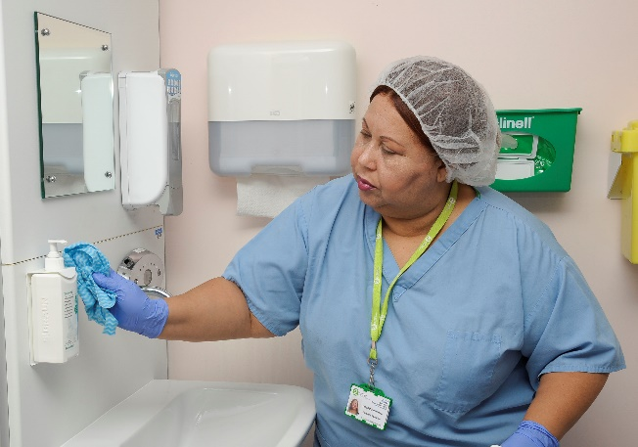
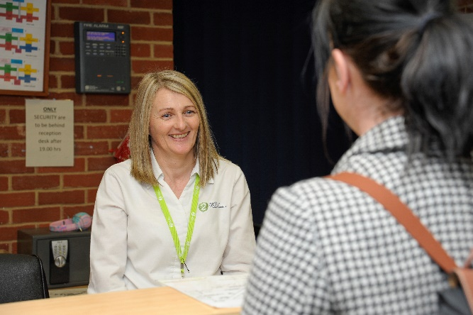
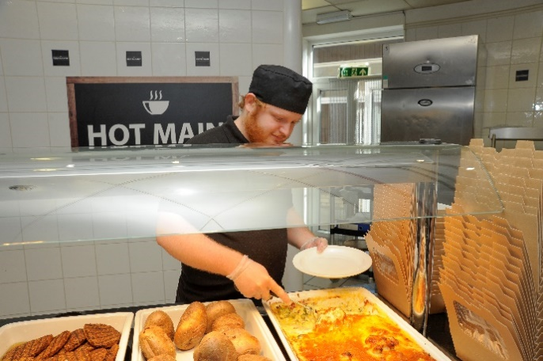
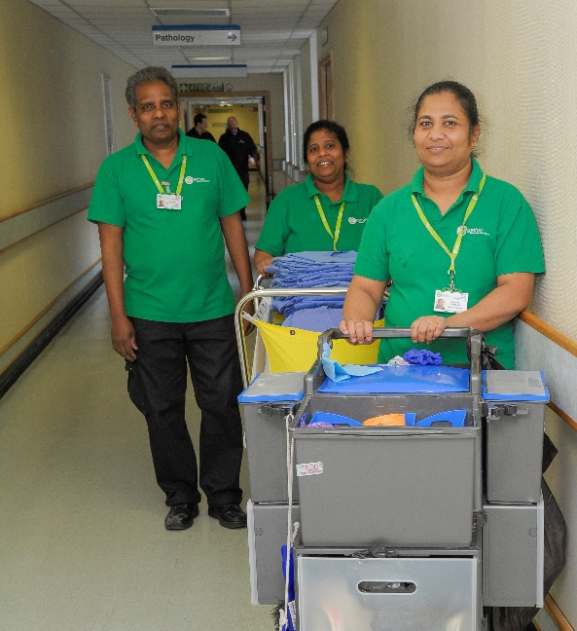

Candidate
Catering Assistant

information
Catering Assistant

Thank you for your interest in the Catering Assistant role here at 2gether Support Solutions. This is a great time to join us as we continue our journey to be recognised as an employer of choice in East Kent.

We want to recruit people who share our ambition and vision to deliver a high standard of service. We understand that our teams make an important difference to patients, visitors and clinical staff; and having the right people in the right roles is crucial to this.

Our in-house talent team look forward to receiving your application and I wish you the best of luck.

Jacqui Siggers, People Director

Our recruitment process
2
If selected, our talent team will be in touch to discuss your experience and the role further in a short phone call.
3
If successful, you will interview on-site with the line manager.

4
If successful, we will make you an offer and help you through compliance.

5
You will complete your induction and become a member of the 2gether team.

1
You complete a simple online application form, and upload your cv.
















About 2gether Support Solutions

We were formed in 2018, by East Kent Hospitals University NHS Foundation Trust (EKHUFT),
and provide total facilities management services along with a range of business support
including procurement, medical engineering and capital build projects.

2gether Support Solutions employs over 1,300 people and our core customer is East Kent Hospitals, managing five hospitals over 210,000sqm of estate at:

- William Harvey Hospital in Ashford,
- Queen Elizabeth The Queen Mother Hospital in Margate,
- Buckland Hospital in Dover,
- Royal Victoria Hospital in Folkestone; and
- Kent and Canterbury Hospital in Canterbury.

Now is a really exciting time to join 2gether, as the company continues to play a key role in supporting local communities, staff and clinical care. Find out more about what we do by visiting www.2getherSupportSolutions.org

What we are all about

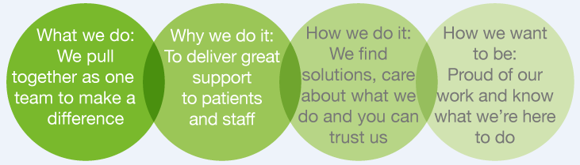

How to apply

Via our website: https://2gethersupportsolutions.org/careers/

By email: 2gether.recruitment@nhs.net

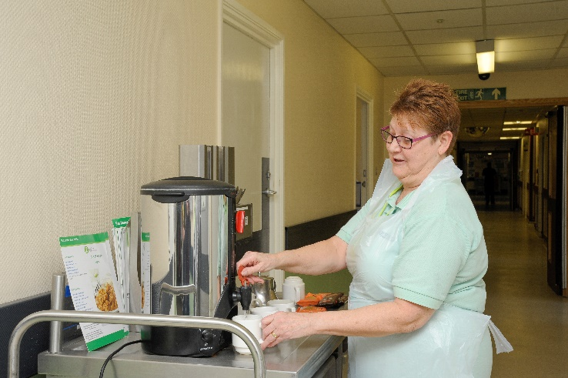
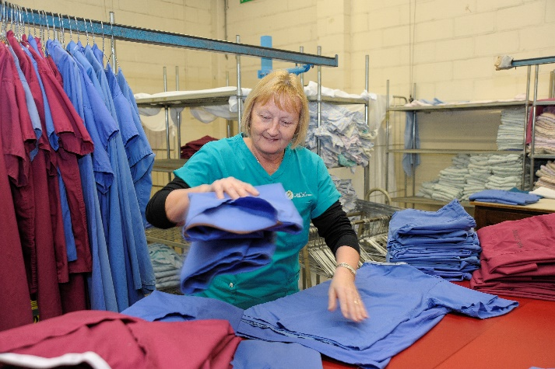
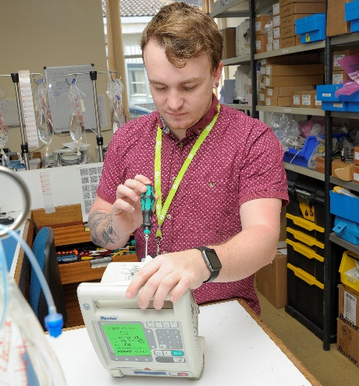

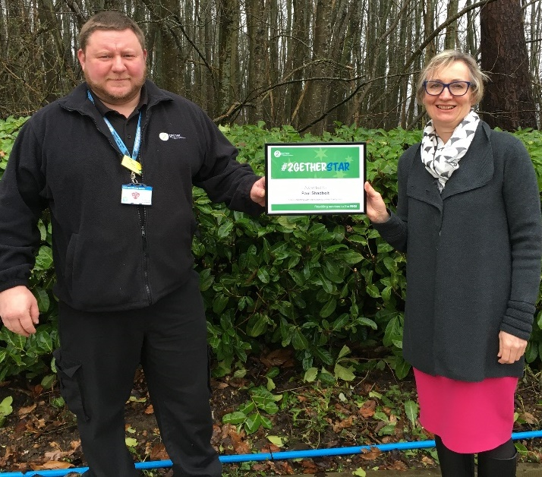

Organisation chart (to be supplied by department)

Job Description

Role title: Catering Assistant | Role reference:
Summary of the role:  To help provide a catering service that meets the expectations of the patients, staff and visitors both in terms of quality, safety and value for money. |  | Reports to: Catering Supervisor
 |  | Base / location: TBC
Key responsibilities |  | Working relationships & contacts
- Provide a courteous and efficient catering service to patients, staff and visitors, optimising the productivity of the retail outlets.  - Prepare and/or serve food to customers in a professional and courteous manner. Optimising retail sales and demonstrating high levels of customer service.  - Cleaning of catering and service equipment including floors, work surfaces, and related equipment manually and by use of machine to hygiene standards.  - Assist in the delivery of the function and vending service within time constraints and meeting stated requirements.  - Operate a cash register and handle cash in a safe and efficient manner.  - To maintain food safety and hygiene standards in your work area and apply the food safety procedures applicable in work area.  - Ensure that all work is carried out in line with Health and Safety, Quality and 2gether Support Solutions policies and procedures and all documentation and work records are completed accurately.  - To correctly use and take care of all equipment and materials associated with tasks and immediately report any faults to a supervisor.  - Store goods correctly and use stock on a rotational basis to optimise sales and minimise food wastage.  - Participate as a full member of the team, e.g. supporting and training other staff, participating in team meetings, working flexibly as required to cover other members of the team.  - Undertake other ad hoc duties as prescribed by manager and within scope of skill and capability |  | Internal: Colleagues and other members of staff within the company that are on shift.  External: Customers, patients, visitors and maintenance/repair staff.
Performance measures and key performance indicators (KPIs)
(If required)
Person Specification

Person Specification

(E) – Essential, (D) – Desirable

Knowledge and Skills: | Experience: | Qualifications and Professional Memberships:
Basic skills training, e.g. Food preparation, Basic Food Hygiene  Requires full knowledge of working practices and procedures  Knowledge of Health and Safety requirements including infection control and Food Hygiene  Good Communication Skills, e.g. communicating with customers and colleagues  Good Customer Care Skills, e.g. for communicating with customers and increasing retail spend  Completing of mandatory training, e.g. manual handling/risk assessment/fire safety training  Able to work to agreed standards and follow work instructions | Experience of working within a busy hospital environment is desirable but not essential. | There are no specific qualification requirements.

Essential Health and Safety information
Does the post involve… |  | Y | N
Confined spaces? | A “confined space” means any enclosed place, such as may need to be accessed by estates staff for maintenance such as loft spaces, plant rooms or flues. |  | X
Driving? | This means driving a company vehicle, passenger carrying vehicle or transporting patients in own vehicle for work purposes. It does not include commuting or driving between places of work. |  | X
Exposure to substances hazardous to health? | This is where risk assessments have identified known health hazards (chemical, biological or radiological). For example, designated latex glove user. |  | X
Hand arm vibration exposure? | This includes hand held tools such as drills, saws, gardening tools, domestic cleaning tools and other power equipment. |  | X
Hand washing? | This means washing hands 20 plus times per working day. | X
Lone working? | This means employees who work by themselves without close or direct supervision. Lone working may be found in a wide range of situations, such as home or community visits, working alone outside normal hours, working in remote or confined areas (such as plant rooms). |  | X
Manual handling? | This means all job roles where there are specific manual handling / patient handling requirements. | X
Night working? | This means regular work at least 3 hours during the agreed ‘night period’ (usually includes 11pm to 6am). |  | X
Noise exposure? | This is where risk assessments have identified noise levels under the Noise at Work Regulations 2005, and is likely to include areas where ear protection is needed or workers regularly have to shout to communicate due to background noise. |  | X
Work at heights? | A place is ‘at height’ if a person could be injured falling from it. This includes working on ladders, up scaffold or any other apparatus. It may also apply to staff who regularly have to stand on kick-stools or steps for significant periods of time to retrieve items/ notes from high shelving. |  | X

