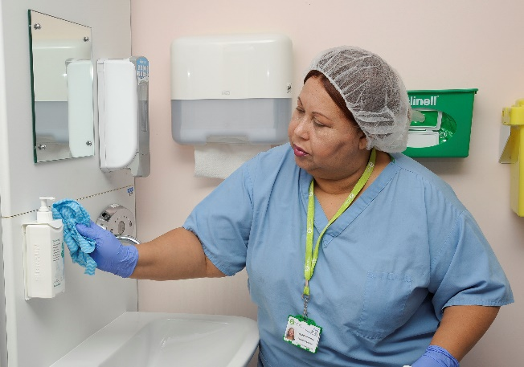
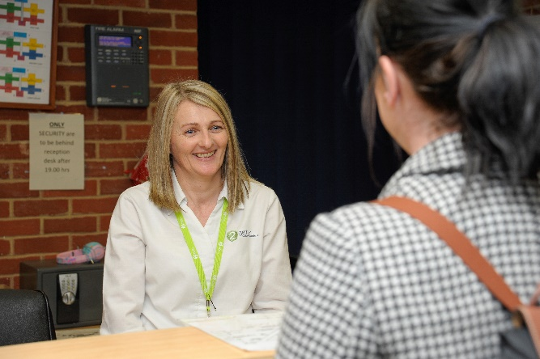
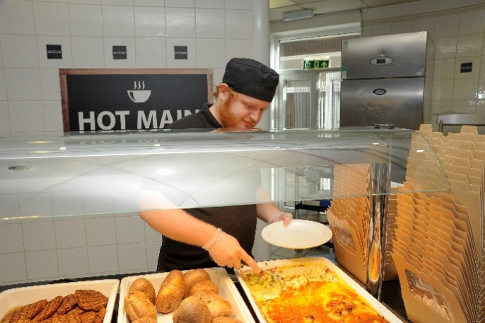
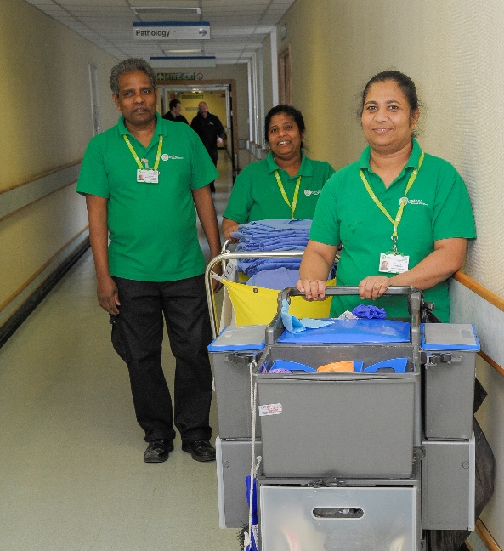
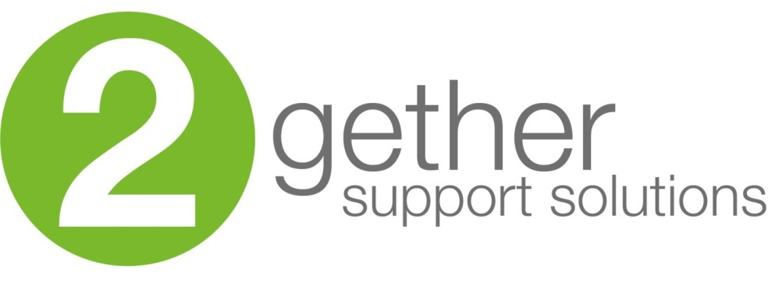
Candidate
Domestic Shift Lead

information
Job Description

Role title: Domestic Shift Lead | Role reference:
Summary of the role:  To provide daily shift lead support to the on-site team ensuring all areas have been covered and reporting any daily concerns to Facilities Management at KCH. The role also performs core housekeeping and cleaning duties within the hospital in accordance with the service level agreement and contract specification. Provide a safe environment for customers and staff. Exceed the expectations of our customers, by effectively doing your duties, ensuring that all standards are consistently met. To perform duties in accordance with infection control training and instruction. |  | Reports to:  Facilities Services Manager KCH
Base / location:
RVH
BHD

Key responsibilities |  | Working relationships & contacts
- To act as shift lead ensuring optimal processing of scheduled work, whilst responding to ad-hoc service requests  - To contribute as a member of the team, providing guidance, direction and working flexibly as required to cover peaks of work stepping in to provide support and cover when required  - Carry out cleaning duties as per cleaning schedule for assigned area.  - Clean all work areas/equipment during and after use and remove all waste to the appropriate area.  - Observe the codes of practice for Health and Safety.  - Ensure that customer complaints are promptly dealt with, and action taken to prevent reoccurrence.  - The equipment is used safely and in accordance with current regulations and company policies and to maintain the equipment in a clean, safe and tidy condition.  - Report all maintenance issues and hazards to your line manager.  - Carry out duties in accordance with agreed Method Statements  - Effective communication with all levels of staff  - Complying with the Trust policies on Health & Safety, COSHH and other statutory legislation  - Advise helpdesk on any defects within own area  - Order of goods and materials as necessary from Team Leaders  - Maintain records as required  - Ensure all security procedures are adhered to at all times.  - Any other cleaning duties required from time to time. |  | Internal: Working with other staff on shift.  External: Assisting with patients and visitors.
Performance measures and key performance indicators (KPIs)
(If required)
Person Specification

Person Specification

(E) – Essential, (D) – Desirable

Knowledge and Skills: | Experience: | Qualifications and Professional Memberships:
Good communication skills including verbal and written English.  Shows initiative and self-motivation.  Awareness of service image.  Physically fit for the work  Friendly and Reliable.  Prepared to work unsociable hours if shift pattern requires.  Attention to detail.  Risk Assessment awareness  Flexible attitude to working times and methods.  Customer focus  Health and Safety Awareness  Site Orientation and Corporate Induction  Manual Handling  Customer Care  Fire Safety | Previous experience of working within a busy hospital environment (D) | BICSc training to Operator Proficiency Certificate Level 1 (OPC L1) (D)  Numerate/literate (E)

Essential Health and Safety information
Does the post involve… |  | Y | N
Confined spaces? | A “confined space” means any enclosed place, such as may need to be accessed by estates staff for maintenance such as loft spaces, plant rooms or flues. |  | X
Driving? | This means driving a company vehicle, passenger carrying vehicle or transporting patients in own vehicle for work purposes. It does not include commuting or driving between places of work. |  | X
Exposure to substances hazardous to health? | This is where risk assessments have identified known health hazards (chemical, biological or radiological). For example, designated latex glove user. |  | X
Hand arm vibration exposure? | This includes hand held tools such as drills, saws, gardening tools, domestic cleaning tools and other power equipment. |  | X
Hand washing? | This means washing hands 20 plus times per working day. | X
Lone working? | This means employees who work by themselves without close or direct supervision. Lone working may be found in a wide range of situations, such as home or community visits, working alone outside normal hours, working in remote or confined areas (such as plant rooms). |  | X
Manual handling? | This means all job roles where there are specific manual handling / patient handling requirements. | X
Night working? | This means regular work at least 3 hours during the agreed ‘night period’ (usually includes 11pm to 6am). | X
Noise exposure? | This is where risk assessments have identified noise levels under the Noise at Work Regulations 2005, and is likely to include areas where ear protection is needed or workers regularly have to shout to communicate due to background noise. |  | X
Work at heights? | A place is ‘at height’ if a person could be injured falling from it. This includes working on ladders, up scaffold or any other apparatus. It may also apply to staff who regularly have to stand on kick-stools or steps for significant periods of time to retrieve items/ notes from high shelving. |  | X

