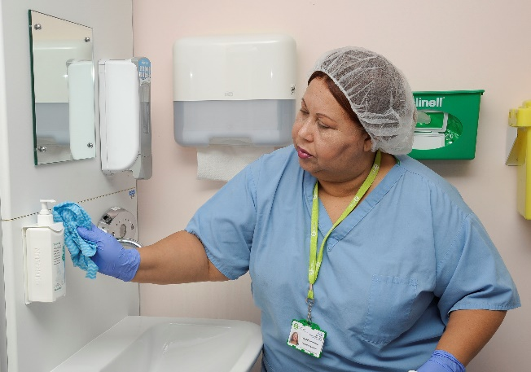
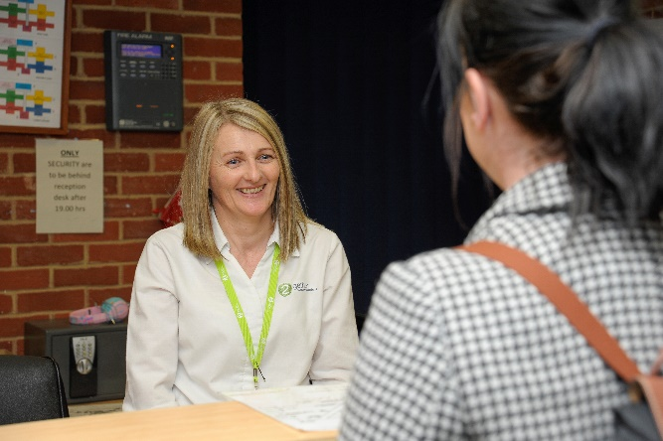
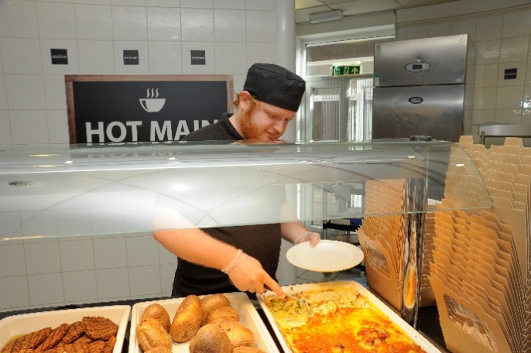
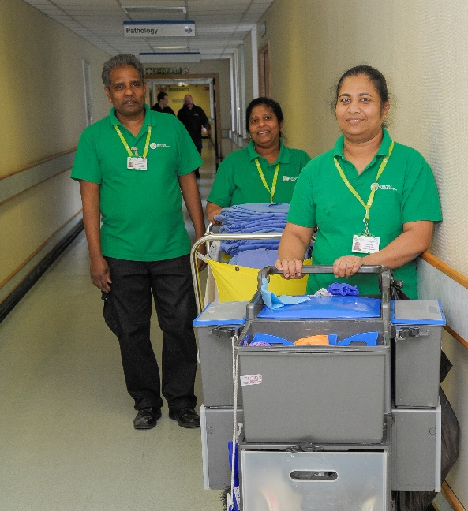
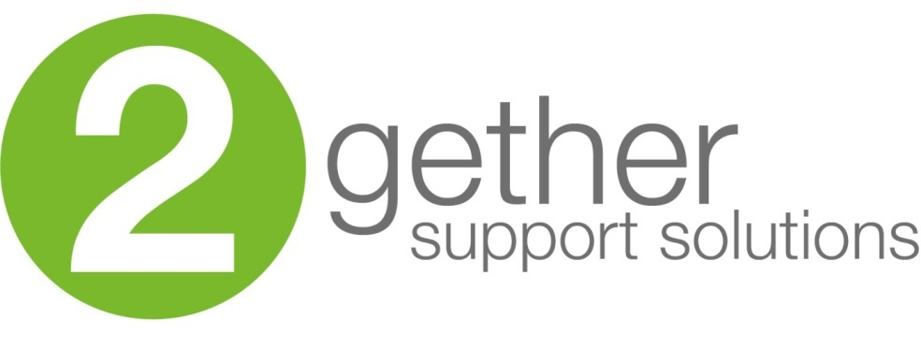
Candidate
Domestic Assistant

information
Domestic Assistant

Thank you for your interest in the Domestic Assistant role here at 2gether Support Solutions. This is a great time to join us as we continue our journey to be recognised as an employer of choice in East Kent.

We want to recruit people who share our ambition and vision to deliver a high standard of service. We understand that our teams make an important difference to patients, visitors and clinical staff; and having the right people in the right roles is crucial to this.

Our in-house talent team look forward to receiving your application and I wish you the best of luck.

Jacqui Siggers, People Director

Our recruitment process
2
If selected, our talent team will be in touch to discuss your experience and the role further in a short phone call.
3
If successful, you will interview on-site with the line manager.

4
If successful, we will make you an offer and help you through compliance.

5
You will complete your induction and become a member of the 2gether team.

1
You complete a simple online application form, and upload your cv.
















About 2gether Support Solutions

We were formed in 2018, by East Kent Hospitals University NHS Foundation Trust (EKHUFT),
and provide total facilities management services along with a range of business support
including procurement, medical engineering and capital build projects.

2gether Support Solutions employs over 1,300 people and our core customer is East Kent Hospitals, managing five hospitals over 210,000sqm of estate at:

- William Harvey Hospital in Ashford,
- Queen Elizabeth The Queen Mother Hospital in Margate,
- Buckland Hospital in Dover,
- Royal Victoria Hospital in Folkestone; and
- Kent and Canterbury Hospital in Canterbury.

Now is a really exciting time to join 2gether, as the company continues to play a key role in supporting local communities, staff and clinical care. Find out more about what we do by visiting www.2getherSupportSolutions.org

What we are all about

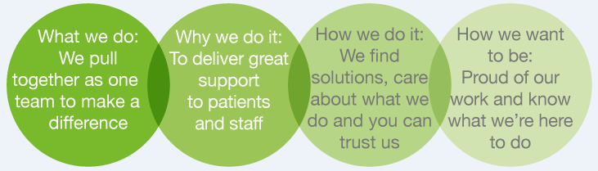

How to apply

Via our website: https://2gethersupportsolutions.org/careers/

By email: 2gether.recruitment@nhs.net

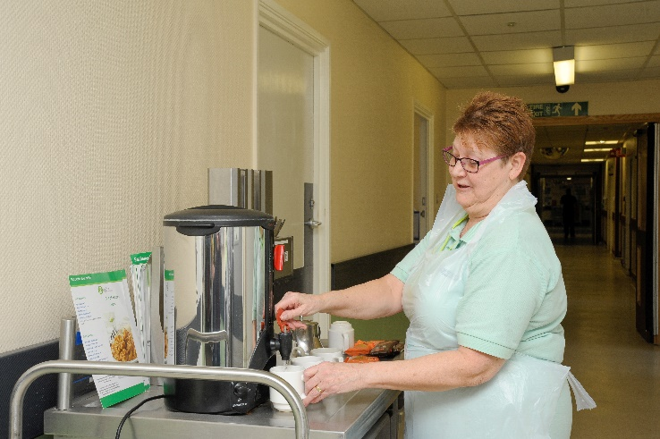
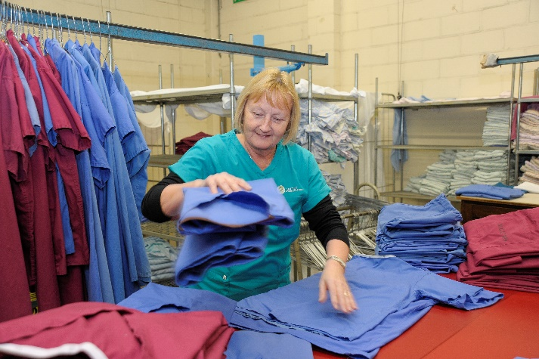
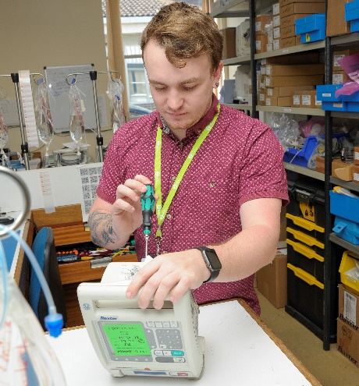
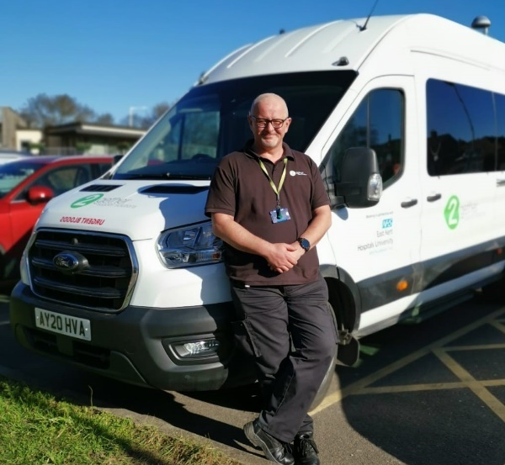
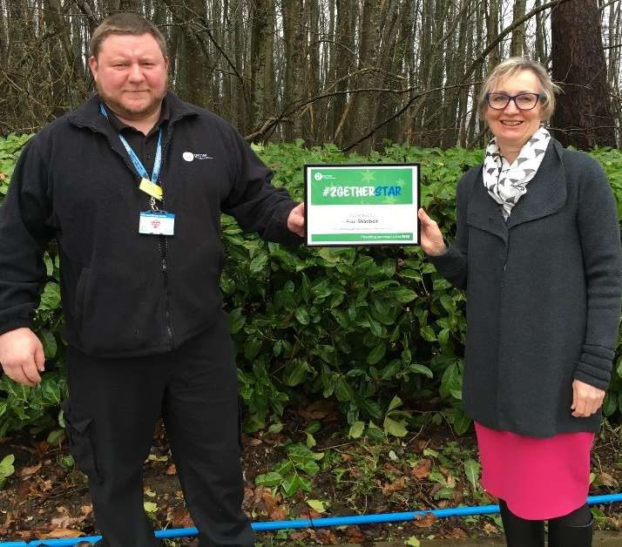

Organisation chart (to be supplied by department)

Job Description

Role title: Domestic Assistant | Role reference:
Summary of the role:  To perform housekeeping and cleaning duties within the hospital in accordance with the service level agreement and contract specification. Provide a safe environment for customers and staff. Exceed the expectations of our customers, by effectively doing your duties, ensuring that all standards are consistently met. To perform duties in accordance with infection control training and instruction. |  | Reports to:  Customer Support Team Leaders
Base / location:
TBC

Key responsibilities |  | Working relationships & contacts
- Carry out cleaning duties as per cleaning schedule for assigned area.  - Clean all work areas/equipment during and after use and remove all waste to the appropriate area.  - Observe the codes of practice for Health and Safety.  - Ensure that customer complaints are promptly dealt with, and action taken to prevent reoccurrence.  - The equipment is used safely and in accordance with current regulations and company policies and to maintain the equipment in a clean, safe and tidy condition.  - Report all maintenance issues and hazards to your line manager.  - Carry out duties in accordance with agreed Method Statements  - Effective communication with all levels of staff  - Complying with the Trust policies on Health & Safety, COSHH and other statutory legislation  - Advise helpdesk on any defects within own area  - Order of goods and materials as necessary from Team Leaders  - Maintain records as required  - Ensure all security procedures are adhered to at all times.  - Any other cleaning duties required from time to time. |  | Internal: Working with other staff on shift.  External: Assisting with patients and visitors.
Performance measures and key performance indicators (KPIs)
(If required)

Person Specification

Person Specification

(E) – Essential, (D) – Desirable

Knowledge and Skills: | Experience: | Qualifications and Professional Memberships:
Good communication skills including verbal and written English.  Shows initiative and self-motivation.  Awareness of service image.  Physically fit for the work  Friendly and Reliable.  Prepared to work unsociable hours if shift pattern requires.  Attention to detail.  Risk Assessment awareness  Flexible attitude to working times and methods.  Customer focus  Health and Safety Awareness  Site Orientation and Corporate Induction  Manual Handling  Customer Care  Fire Safety | Previous experience of working within a busy hospital environment (D) | BICSc training to Operator Proficiency Certificate Level 1 (OPC L1) (D)  Numerate/literate (E)

Essential Health and Safety information
Does the post involve… |  | Y | N
Confined spaces? | A “confined space” means any enclosed place, such as may need to be accessed by estates staff for maintenance such as loft spaces, plant rooms or flues. |  | X
Driving? | This means driving a company vehicle, passenger carrying vehicle or transporting patients in own vehicle for work purposes. It does not include commuting or driving between places of work. |  | X
Exposure to substances hazardous to health? | This is where risk assessments have identified known health hazards (chemical, biological or radiological). For example, designated latex glove user. |  | X
Hand arm vibration exposure? | This includes hand held tools such as drills, saws, gardening tools, domestic cleaning tools and other power equipment. |  | X
Hand washing? | This means washing hands 20 plus times per working day. | X
Lone working? | This means employees who work by themselves without close or direct supervision. Lone working may be found in a wide range of situations, such as home or community visits, working alone outside normal hours, working in remote or confined areas (such as plant rooms). |  | X
Manual handling? | This means all job roles where there are specific manual handling / patient handling requirements. | X
Night working? | This means regular work at least 3 hours during the agreed ‘night period’ (usually includes 11pm to 6am). | X
Noise exposure? | This is where risk assessments have identified noise levels under the Noise at Work Regulations 2005, and is likely to include areas where ear protection is needed or workers regularly have to shout to communicate due to background noise. |  | X
Work at heights? | A place is ‘at height’ if a person could be injured falling from it. This includes working on ladders, up scaffold or any other apparatus. It may also apply to staff who regularly have to stand on kick-stools or steps for significant periods of time to retrieve items/ notes from high shelving. |  | X

