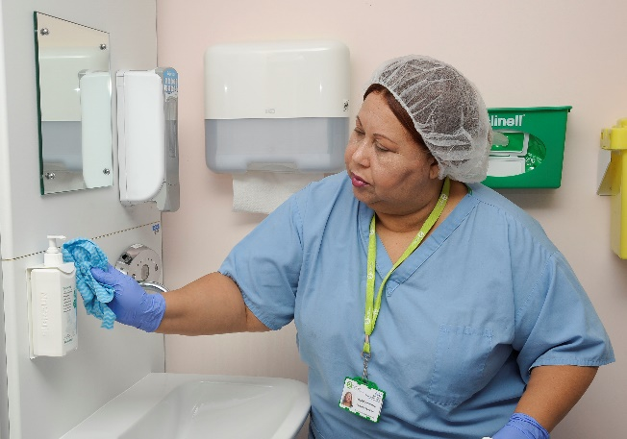
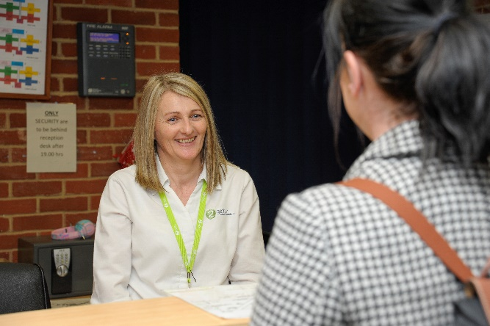
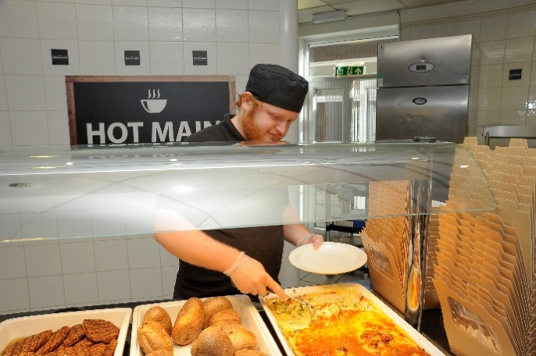
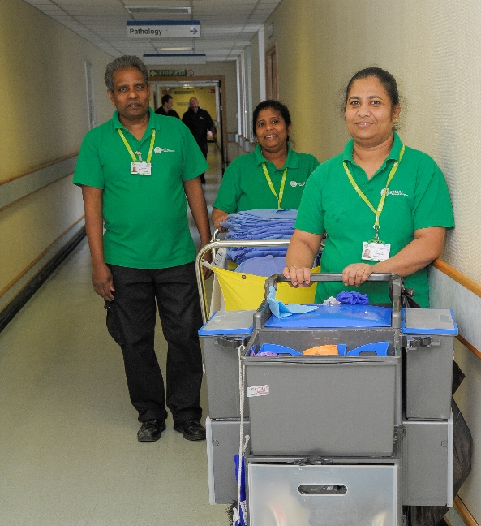

Senior People Advisor

Candidate
information
Job Description

Role title: Senior People Advisor | Role reference: JD224
Summary of the role:  The Senior People Advisor is accountable for managing the provision of high quality and comprehensive advice on a range of ER matters to all business areas with an emphasis on early and/ or informal resolution of cases, including disputes and grievances, wherever possible. This role will line manage 2 site-based People Advisors (based at Ashford and Margate) and will take oversight of all ER advice at Canterbury (and Dover and Folkestone) hospitals, and all non-site-based service areas. |  | Reports to: Head of People
Base / location:

KCH with travel to all other sites
Key responsibilities |  | Working relationships & contacts
- To act as first point of contact for ER queries relating to Canterbury, Folkestone and Dover, and act as the point of escalation for complex cases requiring additional oversight for other sites.  - To actively advise, coach and assist managers when dealing with complex ER issues under 2gether Policies and Procedures such as; poor performance, sickness absence, disciplinary and grievance matters, organisational change, TUPE transfers, collective grievances, and any other issues relating to employment and terms and conditions of service.  - Lead, mentor, support, and develop team, managing all people and performance-related responsibilities.  - To oversee the management of all ER cases and issues with sensitivity and due regard to confidentiality adopting an early resolution and preventative approach wherever possible. Actively manage all cases arising at Canterbury hospital (including Dover and Folkestone) and non-site-based service areas.  - Support the preparation of any materials required to defend Employment Tribunal claims and attend hearings as necessary.  - Work collaboratively with the People Business Partner and Head of People on specific projects as required. In line with the People Strategy, support the development and implementation of key initiatives or changes, ensuring clear communication with site stakeholders.  - Understand, analyse and assess the ER data, information and trends that exist within 2gether. Recommend appropriate action or intervention and propose remedial action to correct and improve employee and management understanding and adherence to policies.  - Provide support with investigations, coaching through process and development of reports of findings, attending formal ER meetings/Hearings and appeals where necessary to advise on policy, good HR practice and Employment Law.  - Assist the business in all aspects of change management including transfer of undertakings (TUPE) situations to ensure that change, where possible, is planned, managed and implemented in accordance with policies whilst enabling them to meet their corporate objectives.  - Assist the People Director with formal meetings with the recognised trade unions including consultation about changes as they affect the workforce or business areas and negotiation.  - Deliver management development training focused on policy and process understanding to ensure that managers are equipped with the necessary skills required to manage staff ensuring these are in line with the company’s objectives and values.  - Review Employment Policies and Procedures ensuring they are in line with best practice and relevant employment legislation.  - Ensuring engagement is maintained throughout all sites, and assist managers with involving staff in engagement activities working alongside the Engagement and Communications manager.  - Lead strategic Equalities, Diversity and Inclusion (EDI) input into key organisational processes, such as reasonable adjustments, recruitment and selection, a leadership framework and performance management appraisals  - Provide advice and support on HR issues for all staff groups.  - Lead on identifying and interpreting developments in case law and external best practice and feed this back to policy working group and People team to ensure all policies and practices are up to date with legislation developments.  - Work closely with Union representatives, liaising with any changes within the business and matters arising within the business.  - Play an active role in Partnership forums alongside Unions and other management to include discussions and negations around pay, change and other business matters as and when required.  - Any other duties commensurate with the grade. |  | - Managers and colleagues  - Leadership team  - External suppliers (such as payroll, training etc)  - Trade union officials and representatives  - Local government and NHS bodies  - Suppliers of goods and services  - Group company HR leads  - Solicitors  - Relevant professional bodies
Performance measures and key performance indicators (KPIs)
(If required)

Person Specification

Person Specification

(E) – Essential, (D) – Desirable

Knowledge and Skills: | Experience: | Qualifications and Professional Memberships:
Strong internal drive & enthusiasm (E)  Ability to juggle several priorities - time management (E)  Excellent presentation and communication skills (E)  Excellent interpersonal and influencing skills including diplomacy and tact (E)  Ability to present information logically and concisely both verbally and in writing (E)  Ability to plan and deliver training courses (E)  Ability to deal with difficult situations (E)  Good analytical skills (E)  Ability to work autonomously  (E)  Knowledge of best employment practice and employment legislation (E) | Previous experience in a generalist human resources role, specifically experience of advising and managing ER cases (E)  Prior experience managing, mentoring or developing a team (E)  Experience managing and influencing senior stakeholders (E) | Appropriate degree or equivalent experience (E)  CIPD qualified minimum Level 5 working towards Level 7 (E)

Essential Health and Safety information
Does the post involve… |  | Y | N
Confined spaces? | A “confined space” means any enclosed place, such as may need to be accessed by estates staff for maintenance such as loft spaces, plant rooms or flues. |  | X
Driving? | This means driving a company vehicle, passenger carrying vehicle or transporting patients in own vehicle for work purposes. It does not include commuting or driving between places of work. |  | X
Exposure to substances hazardous to health? | This is where risk assessments have identified known health hazards (chemical, biological or radiological). For example, designated latex glove user. |  | X
Hand arm vibration exposure? | This includes hand held tools such as drills, saws, gardening tools, domestic cleaning tools and other power equipment. |  | X
Hand washing? | This means washing hands 20 plus times per working day. |  | X
Lone working? | This means employees who work by themselves without close or direct supervision. Lone working may be found in a wide range of situations, such as home or community visits, working alone outside normal hours, working in remote or confined areas (such as plant rooms). |  | X
Manual handling? | This means all job roles where there are specific manual handling / patient handling requirements. |  | X
Night working? | This means regular work at least 3 hours during the agreed ‘night period’ (usually includes 11pm to 6am). |  | X
Noise exposure? | This is where risk assessments have identified noise levels under the Noise at Work Regulations 2005, and is likely to include areas where ear protection is needed or workers regularly have to shout to communicate due to background noise. |  | X
Work at heights? | A place is ‘at height’ if a person could be injured falling from it. This includes working on ladders, up scaffold or any other apparatus. It may also apply to staff who regularly have to stand on kick-stools or steps for significant periods of time to retrieve items/ notes from high shelving. |  | X

